Collect and Sunday Readings
Sunday 19th July 2020
(The Sixth Sunday after Trinity)
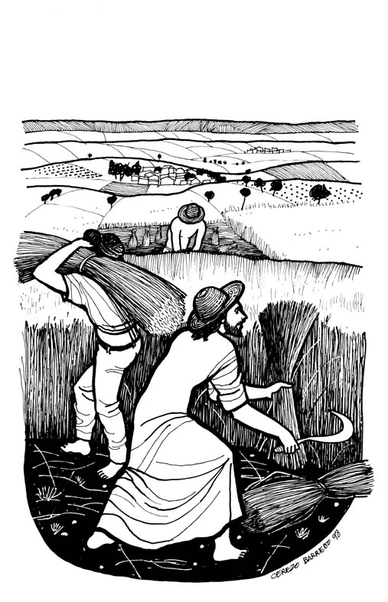
Collect
Merciful God,
you have prepared for those who love you
such good things as pass our understanding:
Pour into our hearts such love toward you
that we, loving you above all things,
may obtain your promises,
which exceed all that we can desire;
through Jesus Christ our Lord.

Wisdom 12:13, 16-19
¹³ For neither is there any god besides you, whose care is for all people,
to whom you should prove that you have not judged unjustly;
¹⁶ For your strength is the source of righteousness,
and your sovereignty over all causes you to spare all.
¹⁷ For you show your strength when people doubt the completeness of your power,
and you rebuke any insolence among those who know it.
¹⁸ Although you are sovereign in strength, you judge with mildness,
and with great forbearance you govern us;
for you have power to act whenever you choose.
¹⁹ Through such works you have taught your people
that the righteous must be kind,
and you have filled your children with good hope,
because you give repentance for sins.

Psalm 86:11-17
11 Teach me your way, O Lord, and I will walk in your truth;
knit my heart to you, that I may fear your name.
12 I will thank you, O Lord my God, with all my heart,
and glorify your name for evermore;
13 For great is your steadfast love towards me,
for you have delivered my soul from the depths of the grave.
14 O God, the proud rise up against me
and a ruthless horde seek after my life;
they have not set you before their eyes.
15 But you, Lord, are gracious and full of compassion,
slow to anger and full of kindness and truth.
16 Turn to me and have mercy upon me;
give your strength to your servant
and save the child of your handmaid.
17 Show me a token of your favour,
that those who hate me may see it and be ashamed;
because you, O Lord, have helped and comforted me.

Matthew 13:24-30,36-43
24 He put before them another parable: ‘The kingdom of heaven may be compared to someone who sowed good seed in his field; ²⁵but while everybody was asleep, an enemy came and sowed weeds among the wheat, and then went away. ²⁶So when the plants came up and bore grain, then the weeds appeared as well. ²⁷And the slaves of the householder came and said to him, “Master, did you not sow good seed in your field? Where, then, did these weeds come from?” ²⁸He answered, “An enemy has done this.” The slaves said to him, “Then do you want us to go and gather them?” ²⁹But he replied, “No; for in gathering the weeds you would uproot the wheat along with them. ³⁰Let both of them grow together until the harvest; and at harvest time I will tell the reapers, Collect the weeds first and bind them in bundles to be burned, but gather the wheat into my barn.” ’
36 Then he left the crowds and went into the house. And his disciples approached him, saying, ‘Explain to us the parable of the weeds of the field.’ ³⁷He answered, ‘The one who sows the good seed is the Son of Man; ³⁸the field is the world, and the good seed are the children of the kingdom; the weeds are the children of the evil one, ³⁹and the enemy who sowed them is the devil; the harvest is the end of the age, and the reapers are angels. ⁴⁰Just as the weeds are collected and burned up with fire, so will it be at the end of the age. ⁴¹The Son of Man will send his angels, and they will collect out of his kingdom all causes of sin and all evildoers, ⁴²and they will throw them into the furnace of fire, where there will be weeping and gnashing of teeth. ⁴³Then the righteous will shine like the sun in the kingdom of their Father. Let anyone with ears* listen!

