Collect and Sunday Readings
Sunday 26th July 2020
(The Seventh Sunday after Trinity)
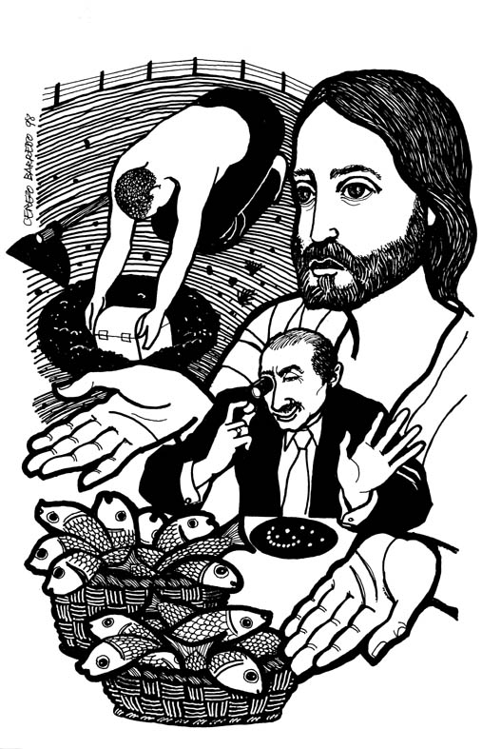
Collect

Lord of all power and might,
the author and giver of all good things:
Graft in our hearts the love of your name,
increase in us true religion,
nourish us with all goodness,
and of your great mercy keep us in the same;
through Jesus Christ our Lord.

1 Kings 3:5-12
⁵ At Gibeon the Lord appeared to Solomon in a dream by night; and God said, “Ask what I should give you.” ⁶ And Solomon said, “You have shown great and steadfast love to your servant my father David, because he walked before you in faithfulness, in righteousness, and in uprightness of heart toward you; and you have kept for him this great and steadfast love, and have given him a son to sit on his throne today. ⁷ And now, O Lord my God, you have made your servant king in place of my father David, although I am only a little child; I do not know how to go out or come in. ⁸ And your servant is in the midst of the people whom you have chosen, a great people, so numerous they cannot be numbered or counted. ⁹ Give your servant therefore an understanding mind to govern your people, able to discern between good and evil; for who can govern this your great people?”
¹⁰ It pleased the Lord that Solomon had asked this. ¹¹ God said to him, “Because you have asked this, and have not asked for yourself long life or riches, or for the life of your enemies, but have asked for yourself understanding to discern what is right, ¹² I now do according to your word. Indeed I give you a wise and discerning mind; no one like you has been before you and no one like you shall arise after you.

Psalm 119:129-136
129 Your testimonies are wonderful;
therefore my soul keeps them.
130 The opening of your word gives light;
it gives understanding to the simple.
131 I open my mouth and draw in my breath,
as I long for your commandments.
132 Turn to me and be gracious to me,
as is your way with those who love your name.
133 Order my steps by your word,
and let no wickedness have dominion over me.
134 Redeem me from earthly oppressors
so that I may keep your commandments.
135 Show the light of your countenance upon your servant
and teach me your statutes.
136 My eyes run down with streams of water,
because the wicked do not keep your law.

Matthew 13:31-33, 44-52
31 He put before them another parable: ‘The kingdom of heaven is like a mustard seed that someone took and sowed in his field; ³²it is the smallest of all the seeds, but when it has grown it is the greatest of shrubs and becomes a tree, so that the birds of the air come and make nests in its branches.’
33 He told them another parable: ‘The kingdom of heaven is like yeast that a woman took and mixed in with* three measures of flour until all of it was leavened.’
44 ‘The kingdom of heaven is like treasure hidden in a field, which someone found and hid; then in his joy he goes and sells all that he has and buys that field.
45 ‘Again, the kingdom of heaven is like a merchant in search of fine pearls; ⁴⁶on finding one pearl of great value, he went and sold all that he had and bought it.
47 ‘Again, the kingdom of heaven is like a net that was thrown into the sea and caught fish of every kind; ⁴⁸when it was full, they drew it ashore, sat down, and put the good into baskets but threw out the bad. ⁴⁹So it will be at the end of the age. The angels will come out and separate the evil from the righteous ⁵⁰and throw them into the furnace of fire, where there will be weeping and gnashing of teeth.
51 ‘Have you understood all this?’ They answered, ‘Yes.’ ⁵²And he said to them, ‘Therefore every scribe who has been trained for the kingdom of heaven is like the master of a household who brings out of his treasure what is new and what is old.’

