Collect and Sunday Readings
Sunday 5th July 2020
(The Fourth Sunday after Trinity)

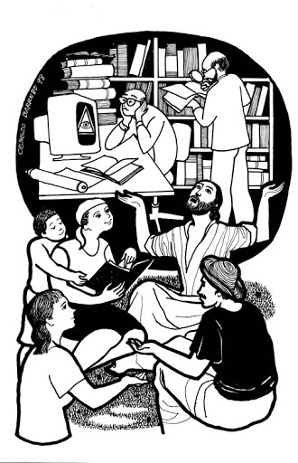
Collect
O God, the protector of all who trust in you,
without whom nothing is strong, nothing is holy:
Increase and multiply upon us your mercy;
that with you as our ruler and guide,
we may so pass through things temporal
that we finally lose not the things eternal:
Grant this, heavenly Father,
for Jesus Christ’s sake, our Lord.
Zechariah 9:9-12
⁹ Rejoice greatly, O daughter Zion!
Shout aloud, O daughter Jerusalem!
Lo, your king comes to you;
triumphant and victorious is he,
humble and riding on a donkey,
on a colt, the foal of a donkey.
¹⁰ He will cut off the chariot from Ephraim
and the war-horse from Jerusalem;
and the battle bow shall be cut off,
and he shall command peace to the nations;
his dominion shall be from sea to sea,
and from the River to the ends of the earth.
¹¹ As for you also, because of the blood of my covenant with you,
I will set your prisoners free from the waterless pit.
¹² Return to your stronghold, O prisoners of hope;
today I declare that I will restore to you double.

Psalm 145:8-15
8 The Lord is gracious and merciful,
long-suffering and of great goodness.
9 The Lord is loving to everyone
and his mercy is over all his creatures.
10 All your works praise you, O Lord,
and your faithful servants bless you.
11 They tell of the glory of your kingdom
and speak of your mighty power,
12 To make known to all peoples your mighty acts
and the glorious splendour of your kingdom.
13 Your kingdom is an everlasting kingdom;
your dominion endures throughout all ages.
14 The Lord is sure in all his words
and faithful in all his deeds.
15 The Lord upholds all those who fall
and lifts up all those who are bowed down.

Matthew 11:16-19, 25-30
¹⁶ “But to what will I compare this generation? It is like children sitting in the marketplaces and calling to one another,
¹⁷ ‘We played the flute for you, and you did not dance;
we wailed, and you did not mourn.’
¹⁸ For John came neither eating nor drinking, and they say, ‘He has a demon’; ¹⁹ the Son of Man came eating and drinking, and they say, ‘Look, a glutton and a drunkard, a friend of tax collectors and sinners!’ Yet wisdom is vindicated by her deeds.”
²⁵ At that time Jesus said, “I thank you, Father, Lord of heaven and earth, because you have hidden these things from the wise and the intelligent and have revealed them to infants; ²⁶ yes, Father, for such was your gracious will. ²⁷ All things have been handed over to me by my Father; and no one knows the Son except the Father, and no one knows the Father except the Son and anyone to whom the Son chooses to reveal him.
²⁸ “Come to me, all you that are weary and are carrying heavy burdens, and I will give you rest. ²⁹ Take my yoke upon you, and learn from me; for I am gentle and humble in heart, and you will find rest for your souls. ³⁰ For my yoke is easy, and my burden is light.”

