Collect and Sunday Readings
Sunday 16th August 2020
(The Tenth Sunday after Trinity)

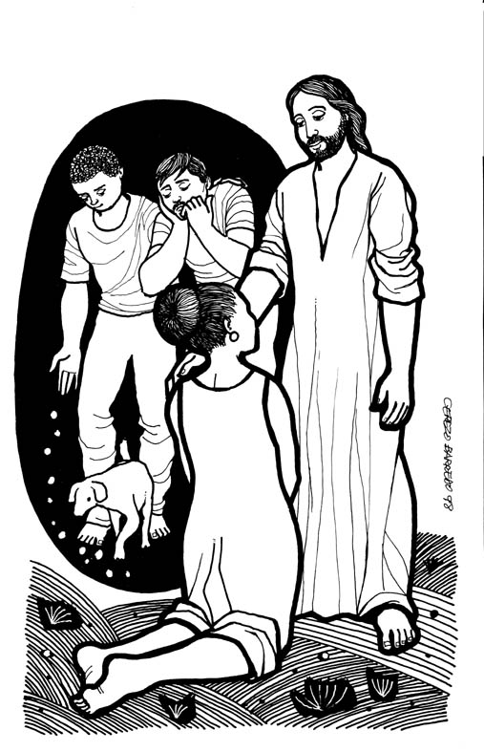
Collect
Let your merciful ears, O Lord,
be open to the prayers of your humble servants;
and that they may obtain their petitions,
make them to ask such things as shall please you;
through Jesus Christ our Lord.

Isaiah 56: 1, 6-8
56Thus says the Lord:
Maintain justice, and do what is right,
for soon my salvation will come,
and my deliverance be revealed.
⁶ And the foreigners who join themselves to the Lord,
to minister to him, to love the name of the Lord,
and to be his servants,
all who keep the sabbath, and do not profane it,
and hold fast my covenant—
⁷ these I will bring to my holy mountain,
and make them joyful in my house of prayer;
their burnt-offerings and their sacrifices
will be accepted on my altar;
for my house shall be called a house of prayer
for all peoples.
⁸ Thus says the Lord God,
who gathers the outcasts of Israel,
I will gather others to them
besides those already gathered.

Psalm 67
1 God be gracious to us and bless us
and make his face to shine upon us,
2 That your way may be known upon earth,
your saving power among all nations.
3 Let the peoples praise you, O God;
let all the peoples praise you.
4 O let the nations rejoice and be glad,
for you will judge the peoples righteously
and govern the nations upon earth.
5 Let the peoples praise you, O God;
let all the peoples praise you.
6 Then shall the earth bring forth her increase,
and God, our own God, will bless us.
7 God will bless us,
and all the ends of the earth shall fear him.

Matthew 15: 21-28
21 Jesus left that place and went away to the district of Tyre and Sidon. ²²Just then a Canaanite woman from that region came out and started shouting, ‘Have mercy on me, Lord, Son of David; my daughter is tormented by a demon.’ ²³But he did not answer her at all. And his disciples came and urged him, saying, ‘Send her away, for she keeps shouting after us.’ ²⁴He answered, ‘I was sent only to the lost sheep of the house of Israel.’ ²⁵But she came and knelt before him, saying, ‘Lord, help me.’ ²⁶He answered, ‘It is not fair to take the children’s food and throw it to the dogs.’ ²⁷She said, ‘Yes, Lord, yet even the dogs eat the crumbs that fall from their masters’ table.’ ²⁸Then Jesus answered her, ‘Woman, great is your faith! Let it be done for you as you wish.’ And her daughter was healed instantly.

