Collect and Sunday Readings
Sunday 23rd August 2020
(The Eleventh Sunday after Trinity)
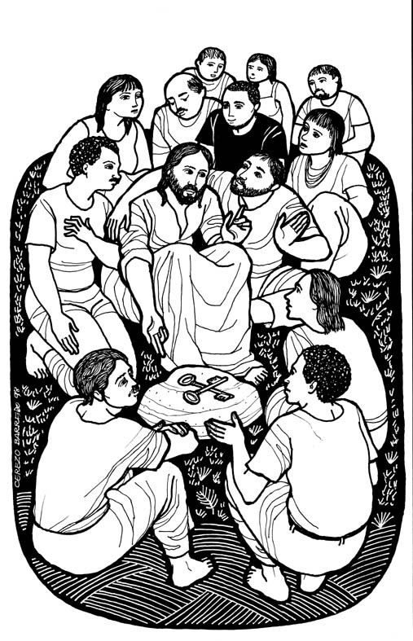
Collect
O God, you declare your almighty power
most chiefly in showing mercy and pity:
Mercifully grant to us such a measure of your grace,
that we, running the way of your commandments,
may receive your gracious promises,
and be made partakers of your heavenly treasure;
through Jesus Christ our Lord.

Isaiah 51: 1-6
51Listen to me, you that pursue righteousness,
you that seek the Lord.
Look to the rock from which you were hewn,
and to the quarry from which you were dug.
² Look to Abraham your father
and to Sarah who bore you;
for he was but one when I called him,
but I blessed him and made him many.
³ For the Lord will comfort Zion; he will comfort all her waste places,
and will make her wilderness like Eden, her desert like the garden of the Lord;
joy and gladness will be found in her, thanksgiving and the voice of song.
⁴ Listen to me, my people, and give heed to me, my nation;
for a teaching will go out from me, and my justice for a light to the peoples.
⁵ I will bring near my deliverance swiftly, my salvation has gone out
and my arms will rule the peoples, the coastlands wait for me,
and for my arm they hope.
⁶ Lift up your eyes to the heavens, and look at the earth beneath;
for the heavens will vanish like smoke, the earth will wear out like a garment,
and those who live on it will die like gnats; but my salvation will be for ever,
and my deliverance will never be ended.

Psalm 138
1 I will give thanks to you, O Lord, with my whole heart;
before the gods will I sing praise to you.
2 I will bow down towards your holy temple and praise your name,
because of your love and faithfulness;
for you have glorified your name
and your word above all things.
3 In the day that I called to you, you answered me;
you put new strength in my soul.
4 All the kings of the earth shall praise you, O Lord,
for they have heard the words of your mouth.
5 They shall sing of the ways of the Lord,
that great is the glory of the Lord.
6 Though the Lord be high, he watches over the lowly;
as for the proud, he regards them from afar.
7 Though I walk in the midst of trouble,
you will preserve me;
you will stretch forth your hand against the fury of my enemies;
your right hand will save me.
8 The Lord shall make good his purpose for me;
your loving-kindness, O Lord, endures for ever;
forsake not the work of your hands.

Matthew 16: 13-20
13 Now when Jesus came into the district of Caesarea Philippi, he asked his disciples, ‘Who do people say that the Son of Man is?’ ¹⁴And they said, ‘Some say John the Baptist, but others Elijah, and still others Jeremiah or one of the prophets.’ ¹⁵He said to them, ‘But who do you say that I am?’ ¹⁶Simon Peter answered, ‘You are the Messiah, the Son of the living God.’ ¹⁷And Jesus answered him, ‘Blessed are you, Simon son of Jonah! For flesh and blood has not revealed this to you, but my Father in heaven. ¹⁸And I tell you, you are Peter, and on this rock I will build my church, and the gates of Hades will not prevail against it. ¹⁹I will give you the keys of the kingdom of heaven, and whatever you bind on earth will be bound in heaven, and whatever you loose on earth will be loosed in heaven.’ ²⁰Then he sternly ordered the disciples not to tell anyone that he was the Messiah.

