Collect and Sunday Readings
Sunday 2nd August 2020
(The Eighth Sunday after Trinity)

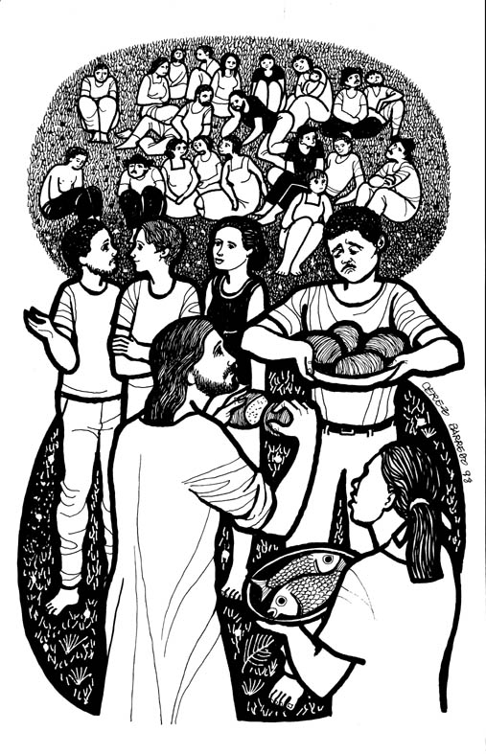
Collect

Blessed are you, O Lord,
and blessed are those who observe and keep your law:
Help us to seek you with our whole heart,
to delight in your commandments
and to walk in the glorious liberty
given us by your Son, Jesus Christ.

Isaiah 55: 1-5
Ho, everyone who thirsts,
come to the waters;
and you that have no money,
come, buy and eat!
Come, buy wine and milk
without money and without price.
² Why do you spend your money for that which is not bread,
and your labour for that which does not satisfy?
Listen carefully to me, and eat what is good,
and delight yourselves in rich food.
³ Incline your ear, and come to me;
listen, so that you may live.
I will make with you an everlasting covenant,
my steadfast, sure love for David.
⁴ See, I made him a witness to the peoples,
a leader and commander for the peoples.
⁵ See, you shall call nations that you do not know,
and nations that do not know you shall run to you,
because of the Lord your God, the Holy One of Israel,
for he has glorified you.

Psalm 145:8-9, 15-22
8 The Lord is gracious and merciful,
long-suffering and of great goodness.
9 The Lord is loving to everyone
and his mercy is over all his creatures.
15 The Lord upholds all those who fall
and lifts up all those who are bowed down.
16 The eyes of all wait upon you, O Lord,
and you give them their food in due season.
17 You open wide your hand
and fill all things living with plenty.
18 The Lord is righteous in all his ways
and loving in all his works.
19 The Lord is near to those who call upon him,
to all who call upon him faithfully.
20 He fulfils the desire of those who fear him;
he hears their cry and saves them.
21 The Lord watches over those who love him,
but all the wicked shall he destroy.
22 My mouth shall speak the praise of the Lord,
and let all flesh bless his holy name for ever and ever.

Matthew 14: 13-21
13 Now when Jesus heard this, he withdrew from there in a boat to a deserted place by himself. But when the crowds heard it, they followed him on foot from the towns. ¹⁴When he went ashore, he saw a great crowd; and he had compassion for them and cured their sick. ¹⁵When it was evening, the disciples came to him and said, ‘This is a deserted place, and the hour is now late; send the crowds away so that they may go into the villages and buy food for themselves.’ ¹⁶Jesus said to them, ‘They need not go away; you give them something to eat.’ ¹⁷They replied, ‘We have nothing here but five loaves and two fish.’ ¹⁸And he said, ‘Bring them here to me.’ ¹⁹Then he ordered the crowds to sit down on the grass. Taking the five loaves and the two fish, he looked up to heaven, and blessed and broke the loaves, and gave them to the disciples, and the disciples gave them to the crowds. ²⁰And all ate and were filled; and they took up what was left over of the broken pieces, twelve baskets full. ²¹And those who ate were about five thousand men, besides women and children.

