Collect and Sunday Readings
Sunday 30th August 2020
(The Twelfth Sunday after Trinity)
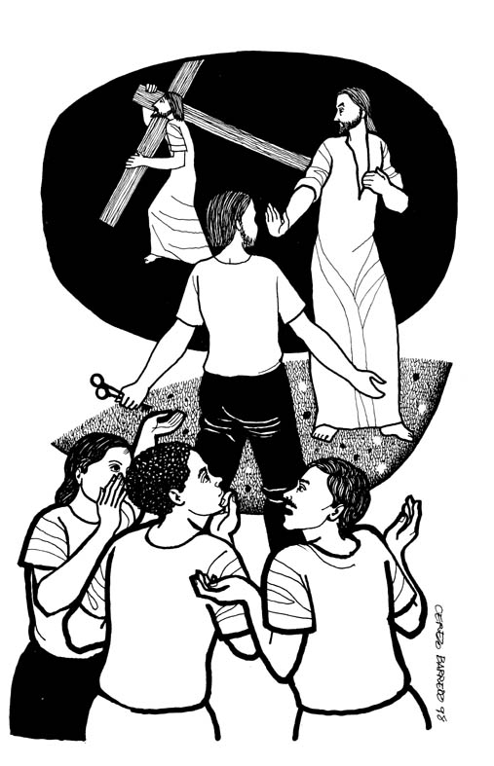
Collect
Almighty and everlasting God,
you are always more ready to hear than we to pray
and to give more than either we desire, or deserve:
Pour down upon us the abundance of your mercy,
forgiving us those things of which our conscience is afraid,
and giving us those good things
which we are not worthy to ask
save through the merits and mediation
of Jesus Christ your Son our Lord.

Jeremiah 15:15-21
¹⁵ O Lord, you know;
remember me and visit me,
and bring down retribution for me on my persecutors.
In your forbearance do not take me away;
know that on your account I suffer insult.
¹⁶ Your words were found, and I ate them,
and your words became to me a joy
and the delight of my heart;
for I am called by your name,
O Lord, God of hosts.
¹⁷ I did not sit in the company of merrymakers,
nor did I rejoice;
under the weight of your hand I sat alone,
for you had filled me with indignation.
¹⁸ Why is my pain unceasing,
my wound incurable,
refusing to be healed?
Truly, you are to me like a deceitful brook,
like waters that fail.
¹⁹ Therefore, thus says the Lord:
If you turn back, I will take you back,
and you shall stand before me.
If you utter what is precious, and not what is worthless,
you shall serve as my mouth.
It is they who will turn to you,
not you who will turn to them.
²⁰ And I will make you to this people
a fortified wall of bronze;
they will fight against you,
but they shall not prevail over you,
for I am with you
to save you and deliver you, says the Lord.
²¹ I will deliver you out of the hand of the wicked,
and redeem you from the grasp of the ruthless.
Psalm 26:1-8
1 Give judgement for me, O Lord,
for I have walked with integrity;
I have trusted in the Lord and have not faltered.
2 Test me, O Lord, and try me;
examine my heart and my mind.
3 For your love is before my eyes;
I have walked in your truth.
4 I have not joined the company of the false,
nor consorted with the deceitful.
5 I hate the gathering of evildoers
and I will not sit down with the wicked.
6 I will wash my hands in innocence, O Lord,
that I may go about your altar,
7 To make heard the voice of thanksgiving
and tell of all your wonderful deeds.
8 Lord, I love the house of your habitation
and the place where your glory abides.

Matthew 16: 21-28
21 From that time on, Jesus began to show his disciples that he must go to Jerusalem and undergo great suffering at the hands of the elders and chief priests and scribes, and be killed, and on the third day be raised. ²²And Peter took him aside and began to rebuke him, saying, ‘God forbid it, Lord! This must never happen to you.’ ²³But he turned and said to Peter, ‘Get behind me, Satan! You are a stumbling-block to me; for you are setting your mind not on divine things but on human things.’
24 Then Jesus told his disciples, ‘If any want to become my followers, let them deny themselves and take up their cross and follow me. ²⁵For those who want to save their life will lose it, and those who lose their life for my sake will find it. ²⁶For what will it profit them if they gain the whole world but forfeit their life? Or what will they give in return for their life?
27 ‘For the Son of Man is to come with his angels in the glory of his Father, and then he will repay everyone for what has been done. ²⁸Truly I tell you, there are some standing here who will not taste death before they see the Son of Man coming in his kingdom.’

