

21st September,2025
14th Sun after Trinity

2nd Sunday before Lent

Collect

O almighty God,
whose blessed Son called Matthew the tax-collector
to be an apostle and evangelist:
Give us grace to forsake the selfish pursuit of gain
and the possessive love of riches;
that we may follow in the way of your Son Jesus Christ,
who is alive and reigns with you and the Holy Spirit,
one God, now and for ever.

First Reading: Proverbs 3: 13-18

Happy are those who find wisdom,
and those who get understanding,
for her income is better than silver,
and her revenue better than gold.
She is more precious than jewels,
and nothing you desire can compare with her.
Long life is in her right hand;
in her left hand are riches and honour.
Her ways are ways of pleasantness,
and all her paths are peace.
She is a tree of life to those who lay hold of her;
those who hold her fast are called happy.

Psalm: 119: 65-72
65 You have dealt graciously with your servant,
according to your word, O Lord.
66 O teach me true understanding and knowledge,
for I have trusted in your commandments.
67 Before I was afflicted I went astray,
but now I keep your word.
68 You are gracious and do good;
O Lord, teach me your statutes.
69 The proud have smeared me with lies,
but I will keep your commandments with my whole heart.
70 Their heart has become gross with fat,
but my delight is in your law.
71 It is good for me that I have been afflicted,
that I may learn your statutes.
72 The law of your mouth is dearer to me
than a hoard of gold and silver.

Second Reading: 2 Corinthians 4: 1-6
Therefore, since it is by God’s mercy that we are engaged in this ministry, we do not lose heart. We have renounced the shameful things that one hides; we refuse to practise cunning or to falsify God’s word; but by the open statement of the truth we commend ourselves to the conscience of everyone in the sight of God. And even if our gospel is veiled, it is veiled to those who are perishing. In their case the god of this world has blinded the minds of the unbelievers, to keep them from seeing the light of the gospel of the glory of Christ, who is the image of God. For we do not proclaim ourselves; we proclaim Jesus Christ as Lord and ourselves as your slaves for Jesus’

sake. For it is the God who said, ‘Let light shine out of darkness’, who has shone in our hearts to give the light of the knowledge of the glory of God in the face of Jesus Christ.

Gospel: Matthew 9: 9-13
As Jesus was walking along, he saw a man called Matthew sitting at the tax booth; and he said to him, ‘Follow me.’ And he got up and followed him.
And as he sat at dinner in the house, many tax-collectors and sinners came and were sitting with him and his disciples. When the Pharisees saw this, they said to his disciples, ‘Why does your teacher eat with tax-collectors and sinners?’ But when he heard this, he said, ‘Those who are well have no need of a physician, but those who are sick. Go and learn what this means, “I desire mercy, not sacrifice.” For I have come to call not the righteous but sinners.’
Post Communion Prayer
God of mercy and compassion,
we have shared the joy of salvation
that Matthew knew when Jesus called him.
Renew our calling to proclaim the one
who came not to call the righteous but sinners to salvation,
your Son Jesus Christ our Lord.

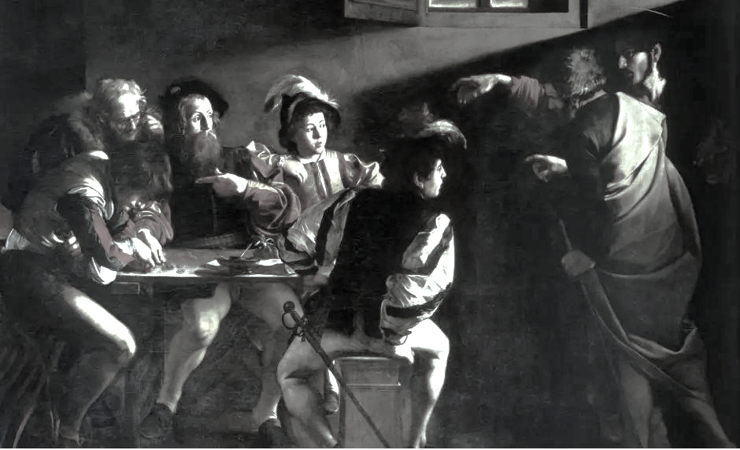


Sunday

Sunday School will begin again on Sunday 21st September in St. Luke’s Church. Collection from the Canon Packham Hall following the 11.15am service

Notices

Visitors are welcome to Diocesan Synod on Saturday 27 September in Bandon Grammar School. As the location is a school campus, security protocol requires that visitors to synod register in advance with the diocesan office. They will be issued a parking pass and an attendance slip which they may exchange at registration for a visitor badge. Visitors will also need a member of Synod to sign them in at registration.

Douglas Churches Together Alpha begins on Tuesday 30th September @7.30pm in Ardfallen Methodist Church on the Douglas Road.

Open Nights – St. Michael’s National School Open Night will take place on Wednesday, 2nd October at 6-7pm followed by St. Luke’s National School Open Night on Wednesday, 8th October at 7-8pm. All are welcome

Confirmation classes will begin on Monday 13th October and conclude on Monday 17th November. Consequently, anyone who would like to be confirmed this year please contact Paula in the parish office for an application form. These forms need to be completed in full and returned to the office by Friday 26th September.

Parish Contacts:
Rev. Dr. William Olhausen Tel: 087/1660356 E-mail:wolhausen@googlemail.com

Parish Office Tel: 4369578. E-mail: douglasofficecork@gmail.com (Friday mornings only)
Parish Website: www.douglas.cork.anglican.org

